Stace Maples

Palo Alto, CA | 214.641.0920 | stacey.maples@gmail.com

6/12/2019

To Whom it May Concern:

I first came to GIS as a frustrated archaeology student. I wanted to do a statistically rigorous examination of site locations in an area just West of Albuquerque, New Mexico, but at the time, I'd no idea that GIS existed. I fumbled for months with USDA soils and historical maps of the area, that I tried to Xerox to overhead projector film and lay onto my sites plotted in pencil on USGS topographic maps. It didn't take me long to realize this was not the way to be doing rigorous archaeological science. By that time, in 1996, I had begun playing around with computer graphics and knew there must be a way to model geographic space and objects, with a computer. I found it at University of North Texas, in Bruce Hunter's lab. During my first ***Introduction to GIS with ArcINFO Workstation*** course, I spent weekends digitizing my survey data (with a digitizing table and puck), which took me only a few weeks to complete. The analysis, a logistic regression, took barely 5 minutes on a UNT computer lab desktop in 1996. I was sold. This was how archaeological data should be managed and analyzed.

Later at University of Texas at Dallas, as an archaeologist learning GIS in a program geared towards municipal GIS and second-career professionals, I found myself struggling to translate what I was learning about modeling water and sewer networks into how I might model prehistoric trade networks. I felt as though I was co-opting tools from another field and forcing them to work for my own. They DID work, but it was a difficult journey to learn to do the things I wanted to do. As I became more adept, I realized that the tools I was working with were really quite discipline agnostic. It was that realization that, once I got over the lack of learning materials in my own application area, made it possible for me to begin doing work that hadn’t been done, before.

For 15 years at Yale and Stanford Universities, I've tried to save other researchers from that learning curve. I've tried to be the person who recognizes that everything is somewhere and that, particularly in research and teaching, that somewhere matters. The programs I've built have focused upon making researchers, from Yale's School of Divinity to Stanford's School of Earth, feel like these tools are for them. That the points, lines, polygons & pixels, and the tools and techniques that we use to analyze them rarely care about the meaning that we as subject specialists bring to them. That these tools really are for everyone and that they are about modeling and understanding "where," in nearly any context we need to understand it.

Over those 15 years, I've also recognized the many pain points and barriers to entry for research and teaching users frrom the need to retain data used in research (including geocodes and their sources), to the difficulty of providing secure services for human subject research, to the idiosyncratic needs of disciplines like archaeology and digital humanities. In my interactions with vendors and service providers, I've tried to always act as an ombudsman for my users and research users, in general, removing the barriers to entry for those not yet infected with the GIS bug.

I've also recognized the opportunities to highlight the kind of impactful work that can be accomplished with effective spatial data tools, when combined with novel research approaches and personal relationships with researchers. These stories provide engaging demonstrations of the power of GIS and spatial data tools, to solve intractable problems. I'll end with one of those stories…

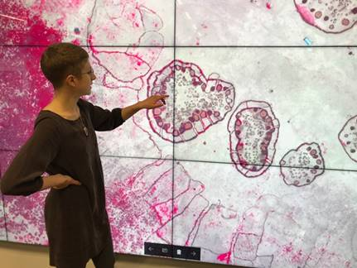**It takes a village to find a village...**

Hannah Binzen Wild is a researcher and Stanford Medical School student. She spent her undergraduate career between Harvard and South Ethiopia, working with the Nyangatom to record their songs and oral literature. She quickly realized that what they really needed were basic public health services and so she adjusted her career path from anthropologist, to doctor.

The Nyangatom are one of the world's last truly nomadic pastoralist cultures. Isolated in the extreme and highly mobile, they live in an area of high conflict and low resources. They have been excluded from virtually all public health needs assessments because they violate one of the assumptions of operationalizing household public health surveys... that 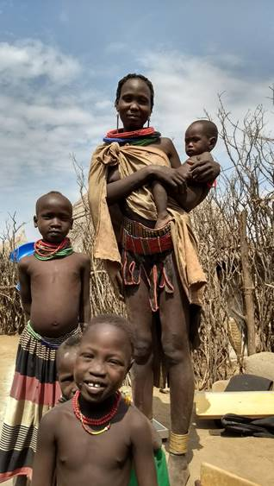people are generally tied to a static geographic location. When Hannah first approached us, she had me pull up Google Maps and zoom to her research area of South Omo. Then, she pointed and said:

*"See that?,... those are Nyangatom settlements. But, this is old imagery and I know that they are gone by now, so this does me no good. Can we get fresh imagery and find all the settlement within 2 or 3 weeks of the image capture? That's what I need to make this survey work."*

Using novel combinations of Open Source software like GDAL, the Humanitarian OpenStreetMap infrastructure, ArcGIS Pro & ArcGIS Online, massive monitors made of 35 HD screen arrays and fast-tracked imagery from the DigitalGlobe Foundation, we did just that. In under 2 weeks, we managed to deliver a randomized settlement survey design to Hannah, based upon a complete settlement survey of over 5,000 square kilometers. Of the 225 settlements we enumerated, only 2 were abandoned by the time she reached them and, in the end, she was able to collect nearly 350 surveys of women of reproductive age, as well as the anthropomorphic measurements and illness histories for more than 800 children, most of whom were under 5.

Pre-print:

<https://www.biorxiv.org/content/10.1101/572685v1.abstract>

 This project continues, now with work being done to generalize the approach in order that it might be applied at scale for a range of applications including outbreaks, conflict, public health survey and refugee settlement management. I hope that it demonstrates the type of work I find most important and most rewarding, and I look forward to discussing the opportunity to support more of this type of work, in the future.

Sincerely,  
Stace Maples